Into Eternity, Lesson 13
Adult Bible Study Guide, 2026 2Q, "Growing in a Relationship With God"

SHARE ON:
 The Teacher's Notes — June 20, 2026
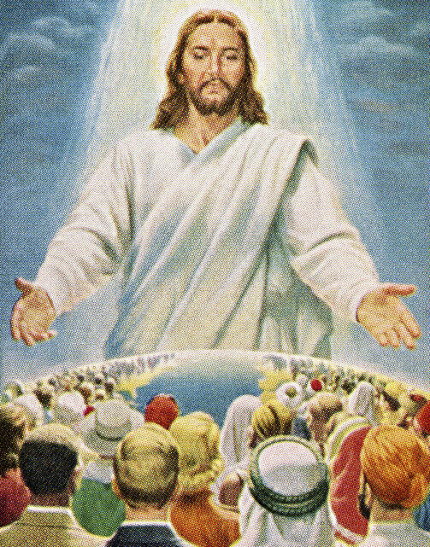
Sabbath School Lesson for June 20-26, 2026
Introduction of Lesson 13, Into Eternity
Memory Text: ” ‘Beloved, now we are children of God; and it has not yet been revealed what we shall be, but we know that when He is revealed, we shall be like Him, for we shall see Him as He is.’ ” 1 John 3:2 NKJV
Setbacks seem to be ongoing, but the Bible predicts they will only increase as time on this earth goes on. In the last days, and especially right at the very end, we’ve been warned about a time of tribulation like never seen before.
Will our relationship with God survive such a tumultuous time? Perhaps it will be strengthened if we remember that He is with us. He drew especially close to Adam, breathing into his nostrils the breath of life at the beginning. We might also expect a close encounter with God at the end, whether that be our end individually, or the end of the world as we know it.
What’s even more fascinating is the thought of what our relationship will be when we do get to heaven. Seeing Jesus face to face is something to look forward to, but the awe-inspiring joy it brings must surely grow even more robust throughout eternity. We surely won’t ever get enough of being in His divine presence.
For more about disasters ahead and how to prepare for them now, see https://www.outlookmag.org/disasters-coming/
This week, we will explore:
- Sunday: Living Today
- Monday: Finally, Face-to-Face
- Tuesday: The Bride
- Wednesday: Follow the Lamb
- Thursday: “Come!”
Sunday: Living Today
Living today may be difficult or easy, but regardless, we must not lose sight of what lies ahead. Many lives are cut short very quickly, so we never know how much time we have to grow a relationship with God. Today might be our last. Only God knows what tomorrow brings.
Asaph, the author of Psalm 80, was the worship leader in the tabernacle. He wrote this psalm as a plea for the restoration of God’s people. He longed to have God’s face shine upon them once again, much the same as we long today for Christ’s return, when He will shine His love upon us as well.
When we have accepted the sacrifice God made for us, we can rest in the knowledge of our ultimate salvation. Each day will be lived as a blessing from God, and God’s love will shine through us to others who need His light in their lives. Our relationship with God is always worth our time and effort. The result of the priestly blessing hinted at in Asaph’s psalm, will lighten our load, when times get rough.
Verses for reflection and discussion:
James 4:13, 14
- Why is life so uncertain these days?
- What difference does it make in how you personally live your life?
Psalm 80:1-3, 14-17, 18, 19
- For what is Asaph appealing to God, and how does it relate to the times we are living in?
Monday: Finally, Face-to-Face
Many eyewitnesses saw and believed that Jesus actually conquered death and rose from the tomb. They saw Him die and they saw His resurrected body with their own eyes, motivating them to share these face-to-face encounters with the world.
Descriptions of His appearing again from the very sky where they last saw Him go back to heaven are repeated throughout Scripture. Jesus promised this glorious reunion in John 14:1-3. When He returns for us, the dead in Christ will rise first, and all the righteous living will join them in that space flight to those heavenly mansions Jesus is preparing for us (1 Thessalonians 4:16, 17).
God made us so we would long to be close to Him. Therefore, it’s no wonder that our desire to see Him again face-to-face is so strong. Recognizing that need, the Bible gives ample information on which to base our hopes. At some point, all creation will see and recognize Him as Lord of the universe (Philippians 2:10, 11). But for the unrighteous, it will be too late, and they will have lost their reward.
Verses for reflection and discussion:
John 14:1-3
- Why is this promise so important to God’s people?
1 Thessalonians 4:16-18
- What do you find most comforting about this happy scene of reunion?
Tuesday: The Bride
The bride is symbolically portrayed as the saints of God. She is “arrayed in fine linen, clean and bright, for the fine linen is the righteous acts of the saints” (Revelation 19:8). Her marriage to the Lamb is truly something to look forward to. We are now called to get ready for that anticipated wedding day, when we will then be by our loving Savior’s side forever.
The fact that the holy city, New Jerusalem, is also called “the bride” in Revelation 21:10, 11, leads us to believe, of course, that the city is full of God’s righteous ones, His saints. The city, too, is beautifully adorned, with walls of jasper, gates of pearl, and streets of gold.
Just as the wedding day is the turning point in the relationship between two people, this glorious scene of our marriage to the Lamb of God will forever change our relationship with Him.
Human couples look forward to their wedding day, and we are likewise reminded to set our minds “on things above, not on things on the earth” (Colossians 3:2). We must do all we can to prepare ourselves for that joyful occasion when Christ returns for His loved ones, His beloved bride.
Verses for reflection and discussion:
Revelation 21:9-12 and Revelation 19:7, 8
- Why are both the saints and the city described as a bride?
- What must the bride do to prepare herself for our marriage to the Lamb–both on a human level, and a spiritual level?
Wednesday: Follow the Lamb
There’s something that sin didn’t change about humanity as a whole. Somehow, we’ve never lost the hope and longing for something beyond this life on earth. Many world religions, now and in the past, express the desire for some kind of afterlife, something better than the pain and suffering we have now.
What perhaps makes Christianity so appealing is its message that salvation doesn’t depend on our paltry, limited efforts. The blood of the Lamb is enough to provide us with the opportunity to live again, and for eternity. Our duty is simply to follow that Lamb wherever He goes. Our righteous acts only mirror His. Our renewed character is but a reflection of the One we follow.
The Lamb, who was slain for our sins, is also our gentle Shepherd who will guide us, the sheep of His pasture, to a new home beyond our wildest dreams. We can only imagine the glory that we’ll share with Him in that Holy City someday.
Verses for reflection and discussion:
Isaiah 25:8 and Revelation 7:17, 21:4
- What are some of the blessings waiting for us in our heavenly home?
Revelation 22:4
- Who are those who will see Jesus face-to-face?
- What is the significance of His name being on their foreheads?
- Why might seeing Jesus be the greatest blessing of all for the followers of Jesus?
Thursday: “Come!”
For all the blessings and joys that will be ours someday in heaven, we can also experience many of the same blessings here on earth when we follow the Lamb. For all who come to Him, He promises restful peace of mind (Matthew 11:28). We are given living waters to refresh our thirsty souls (through prayer), and spiritual food to sustain us (through reading His word).
Just as a faithful shepherd cares for his flock of sheep, so Jesus cares for those who are obedient to His commands–commands designed to keep us safe and free from harm and danger. Our lives are forever changed when we accept His invitation to come to Him when He calls.
God never forces us to come, but His arms are open wide when we believe and surrender our lives fully to His will. His Holy Spirit speaks to our hearts continually, if we will listen and faithfully be guided by our tender Shepherd.
Verses for reflection and discussion:
Matthew 11:28-30
- Why is God’s yoke light and easy to bear?
Isaiah 55:1-3
- Who has paid the price for our salvation?
- Why is it important to remember that our eternal life is free?
John 6:44
- How does the Father draw us to Him?
Friday: Final Thoughts
There’s more to growing our relationship with God than perhaps we realize at first. But, just like our human relationships, especially marriage, our love never stays the same. The more we know about a person, the more we tend to love and appreciate what they do for and with us. The same holds true for our relationship with our heavenly Father.
How beautiful is the thought that our relationship with God is never-ending. Throughout eternity our bond with Him survives and becomes ever more precious to us. In the Holy City, we will have the privilege of being closer to Him than all His other creatures. Our praises to Him will resound throughout the universe.
Let’s not wait to learn all we can about God, our ticket out of this world of sin. God longs to welcome us into His heavenly kingdom of eternal peace and happiness. Someday, we will reside in a city the shape of a cube, 12,000 furlongs in all directions. A city foursquare, with ample room for God and all His children to grow our relationship with each other.
For more about the city foursquare, see https://www.outlookmag.org/the-city-foursquare/
Next Week: Paul’s Ministry in Corinth
To read the Sabbath School Lesson Quarterly and see more resources for its study, go to
https://www.sabbath.school/

