Setbacks, Lesson 11
Adult Bible Study Guide, 2026 2Q, "Growing in a Relationship With God"

 The Teacher's Notes — June 6, 2026
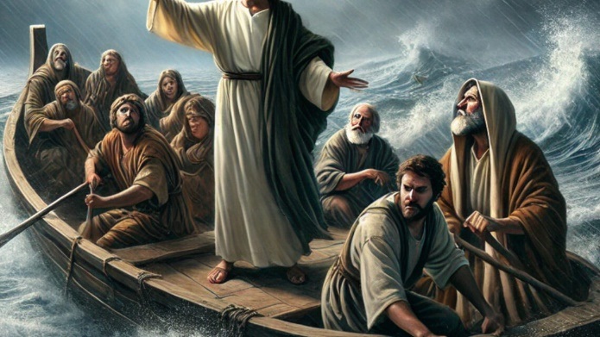
Sabbath School Lesson for June 6-12, 2026
Introduction for Lesson 11, Setbacks
Memory Text: “And not only that, but we also glory in tribulations, knowing that tribulation produces perseverance; and perseverance, character; and character, hope. Now hope does not disappoint, because the love of God has been poured out in our hearts by the Holy Spirit who was given to us.” Romans 5:3-5 NKJV
Even after we’ve begun a relationship with God by repenting and being forgiven, and then by prayer and Bible study feel our faith grow, there can and will be obstacles in our spiritual journey that make our relationship shaky at best.
A humorous story is told about a father who saw his little daughter struggling through a powerful rainstorm. When asked why she kept looking up and smiling every time a bolt of lightning burst through the sky, she told her father that she was smiling because God was taking her picture.
This very-human example reminds us that God is always looking down on us as we struggle here on earth. He keeps a record of everything that happens, the good and the bad. His ever-abiding presence bolsters our faith and is meant to strengthen our relationship with God, helping us make it through the storms of life with increased courage and restored hope.
This week, we will explore:
- Sunday: Life’s Storms
- Monday: Be Made Well
- Tuesday: Job
- Wednesday: The Road to Emmaus
- Thursday: See Jesus
Sunday: Life’s Storms
Many events in life are challenging and difficult to endure, making us feel like we are on stormy seas about to be swallowed up in the gigantic waves that surround us. There was one example of an actual storm that is worth considering and remembering.
Jesus had been given the most comfortable seat in a boat and the only one with a pillow. He and His disciples had launched this boat out on the Sea of Galilee after a tiring day of ministering to the sick and needy. Jesus was so tired that He fell asleep almost immediately, and even failed to wake up when their boat was about to be capsized by a growing, nighttime storm. It was the only time in the Gospels where Jesus is said to be sleeping. He must have felt relaxed and comfortable, knowing the boating skills of His fishermen disciples.
After seeing all the miracles Jesus had performed earlier, the disciples were particularly impressed by the way Jesus addressed the storm and quieted the sea. With only the words, “Peace, be still”, they were shocked to see that the winds and waves, these mighty forces of nature, listened to and obeyed His command.
Verses for reflection and discussion:
Mark 4:35-41
- Why is this story so important to our understanding of God’s power in our lives?
- Why did the disciples question Jesus’ care for them, and how did this indicate their lack of faith?
- When have you also questioned God’s care for you, and why does remembering God’s power and presence give you more faith?
2 Corinthians 5:7
- How can this short verse keep us from questioning God when our lives get stormy?
Monday: Be Made Well
Instead of the disciples’ lack of faith during the storm on the Sea of Galilee, another story is told of a woman who was commended for her faith. They were walking toward the village of Capernaum, and crowds thronged around Jesus, pleading for blessings of one kind or another. A very ill woman had heard of His approach to the town and made the strenuous effort to get as close to Him as possible.
By just getting close enough to touch His garment, she felt she could have her health restored. Her desire paid off, when after a mere touch of the Master, she felt her body renewed and normal, without the issue of blood she had struggled with for so many years.
Jesus felt that touch of faith, too, and longed to see who had been healed. When the woman shyly admitted to being the one whose touch He had felt, Jesus praised her faith, reminding us all that there is a reward when we get as close to God as possible. It wasn’t anything magical in the garment. It was all about her faith in our miracle-working God that had relieved her suffering.
Verses for reflection and discussion:
Mark 5:25-34
- What can we learn about faith from this amazing story?
Hebrews 11:6
- How does our faith contribute to our prayers being answered?
Tuesday: Job
Recognizing that some of us have faith and some of us don’t, one story in the Bible stands out as a demonstration of why we suffer setbacks and why it’s always best to hang onto our faith in God. If anyone had cause to lose faith and become discouraged, it was Job.
Job had lost everything of worth to him–his wealth, his children, and his health. His friends blamed him for his trials. Even his wife saw no reason for Job to go on living when things seemed so hopeless.
Satan is clearly seen as the instigator of Job’s affliction. He did all he could to persuade Job to turn away from God. But instead, Job appealed to God and was rewarded for his steadfast faith. His pronouncement that “I know that my Redeemer lives” (Job 19:25) confirmed his faith and inspires us to hang on to our love for God no matter what obstacles Satan throws in our path.
Verses for reflection and discussion:
Job 1:21
- After losing property and his children, how was Job’s faith in God?
Job 19:23-27 and Job 23:8-12
- What wisdom can you take from Job’s continued trials that might help you survive setbacks in your life?
Wednesday: The Road to Emmaus
Job may have lost all his material blessings on earth, but after Jesus died on the cross, His disciples felt the greatest loss known to man. Heaven itself seemed to have slipped from their fingers, and they were left totally adrift without anything to guide or encourage them.
As two followers of Jesus walked from Jerusalem to the nearby town of Emmaus, confusion and discouragement weighed heavily on their grief-stricken hearts. The news of the resurrection was not widely known yet, but a stranger nevertheless joined them as they travelled and spoke words that lifted their spirits.
This unknown stranger gave them a thorough study of the Scriptures, pointing out prophecies of the risen Lord. This encounter gave them renewed faith that their cause wasn’t so hopeless after all. It wasn’t until they later saw their newfound friend bless the bread they were about to eat that they recognized the “stranger” as Jesus Himself!
Verses for reflection and discussion:
Luke 24:13-27
- How did this “Bible study” with Jesus encourage them to have more faith?
- How does reading and studying the Bible affect your faith journey?
Philippians 4:6 and 2 Corinthians 12:10
- What other promises in the Bible have you found comforting and uplifting when you are discouraged or confused?
Thursday: See Jesus
Daniel’s prediction that in the last days, knowledge would increase and men would run to and fro (Daniel 12:4) has certainly been fulfilled in many ways in our world today. Fields of knowledge: technology, medical science, transportation, communication, and even having the Bible available in so many languages, all reveal an increase in human knowledge like no other time in history. Despite these advantages, or perhaps even because of them, we are more prone than ever to feel the effects of setbacks–not just our own, but those being experienced by people and nations around the globe.
Studying the prophecies about the Messiah in the Old Testament and reading about the life of Christ in the New Testament, coupled with humble praise and prayerful devotional practices, are guaranteed ways to re-focus our vision about life and bring us into a growing relationship with our Creator God.
This is the best remedy to fill the pain we have in our hearts when we are thus overwhelmed by the world’s calamities. Looking to Jesus and seeing Him victorious at last when He returns will bring everything into proper focus and uplift our souls, giving us the courage to go on, with God at our side.
Verses for reflection and discussion:
Romans 8:18, 28
- What is Paul trying to convey in this letter to the Romans?
- How do these verses bring us hope today, when things seem hopeless?
Friday: Final Thoughts
The memory text this week, Romans 5:3-5, is particularly valuable in understanding why we have setbacks, or tribulations. When we respond appropriately to such challenges, they can make us more resilient, and more empathetic to others, bringing us joy and hope in the Lord as never before.
Reminding ourselves of the many promises in the Bible, our walk with God, who never changes (Malachi 3:6), can be maintained and even strengthened. Instead of feeling sad and downtrodden, these circumstances have the potential of drawing us closer to our Lord. James agreed with Paul on this issue. He said in James 1:2-4…
“My brethren, count it all joy when you fall into various trials, knowing that the testing of your faith produces patience. But let patience have its perfect work, that you may be perfect and complete, lacking nothing.”
Next Week: Share Him
To read the Sabbath School Lesson Quarterly and see more resources for its study, go to
https://www.sabbath.school/

